Step-by-Step: Installing Xprint

| August-20 |

**Document Overview**

**Documentation Goals**

This documentation is intended to provide step by step instructions for ***installing XPrint****.*

# **XPrint Installation**

***“Double-Click”*** on the *xPrint6* icon in order to open the Setup Wizard.

#### Welcome Screen

Select the ***“Next”*** button at the bottom of the screen.

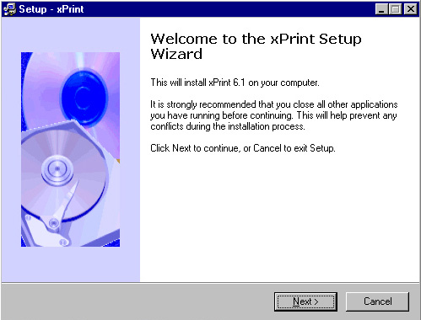

#### License Agreement Screen

Select the ***“Yes”*** button at the bottom of the screen in order to accept the License Agreement.

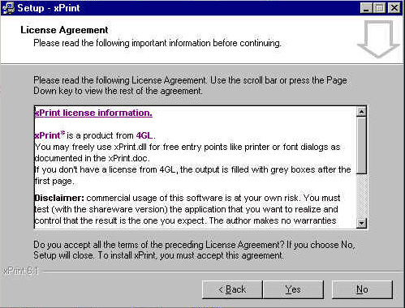

#### Select Destination Location

Keep the default selections on this screen, and do not attempt any changes. Then select the ***“Next”*** button at the bottom of the screen.

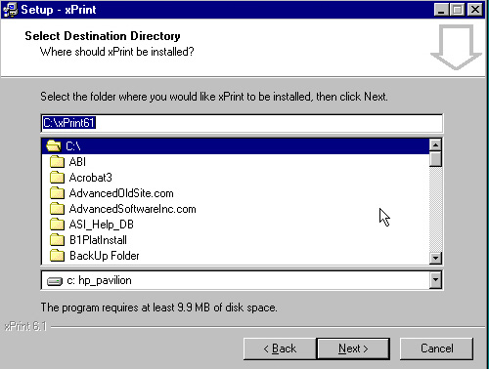

#### Select Progress Binary Directory

Select the *Progress Binary Directory* from the list. Please take note of the path destination of the directory.

Program Files/Progress/bin - this is where you need to install the program files to make it work right. Then select the ***“Next”*** button at the bottom of the screen.

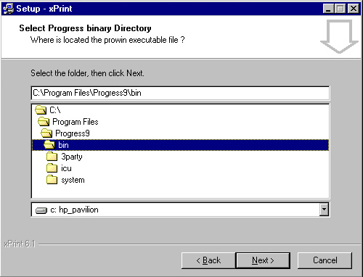

#### Select Start Menu Folder

Keep the default selections on this screen, and do not attempt any changes. Then select the ***“Next”*** button at the bottom of the screen.

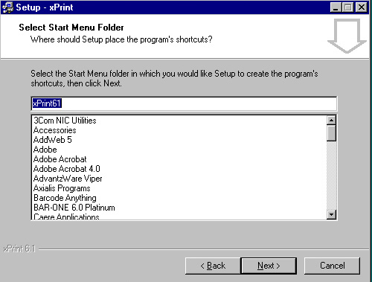

#### Select Additional Tasks

Keep the default selections on this screen, and not attempt any changes. Then select the ***“Next”*** button at the bottom of the screen.

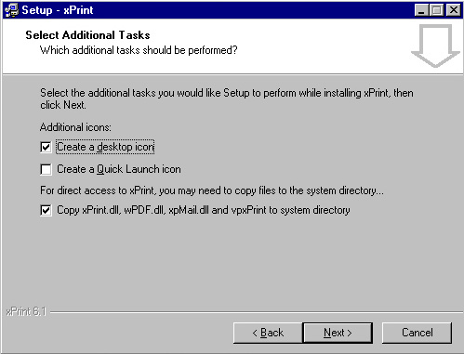

#### Ready to Install Screen

Select the ***“Install”*** button at the bottom of the screen to complete the installation of the software.

